2D Shapes with OpenGL
I have been reading OpenGL Super Bible (the blue book) and decided to put my understanding to a test to see what I know. My aim was to create a simple program where I could draw simple 2D shapes on the screen by passing in vertexes using the console. The focus for me was passing the correct data from the C++ application to each shader using uniforms indexing. At index = 0 I would pass the position data of any shape and at index = 1 would be the colour of a shape.

Simple UML:
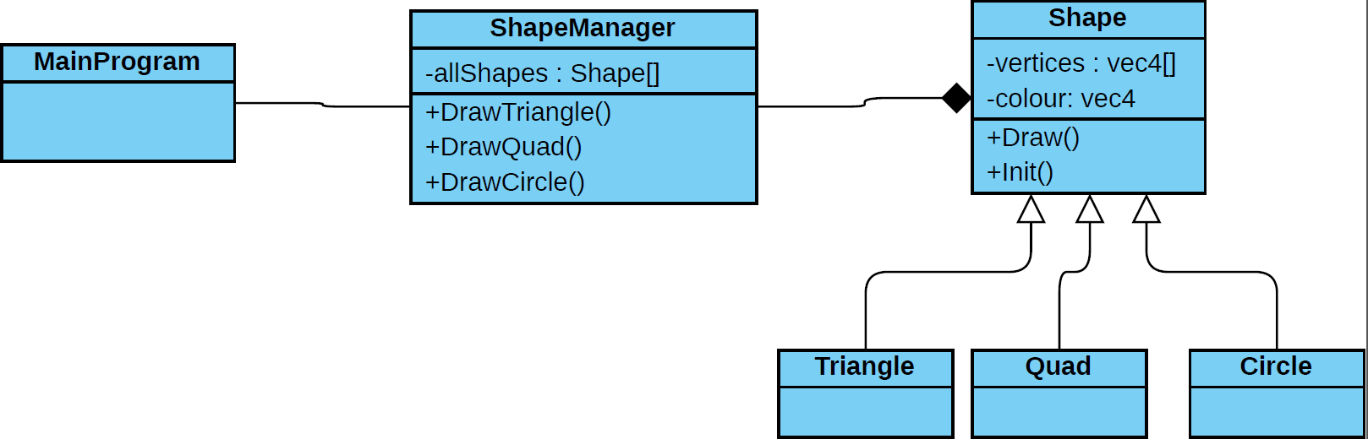
Shaders
So, the first stage was to create the vertex and fragment shaders, so I knew where to pass the data of my shapes.
Vertex:
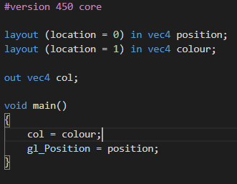
Here I am expecting position to come in at index zero. Then using gl_Position apply that position to the vertex.
For colour I just pass it over to the fragment shader.
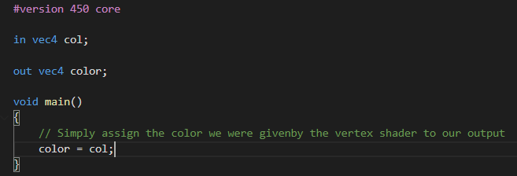

The Application
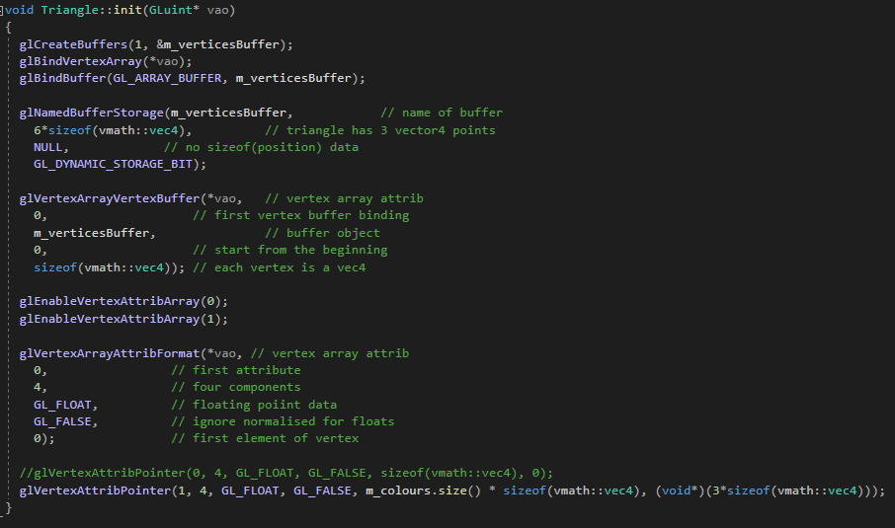

The init function is called when you want to create the memory space that will be used to pass into the shaders.
I create a buffer and bind it the to vertex array object passed in. Then I set the size of the buffer to be 6 * size of vec4 because there are 3 vertices in a triangle and then for each vertex, I set the colour. So, there for 6 vec4.
I then link the vertex (position) data to the vertex buffer, so the program knows its position in the buffer. I also do this for the colour further down
I pass the position data into vertex attrib at index = 0 and colour at index = 1 so I need to enable these.
This then set up an empty buffer ready to be passed into the vertex shader.

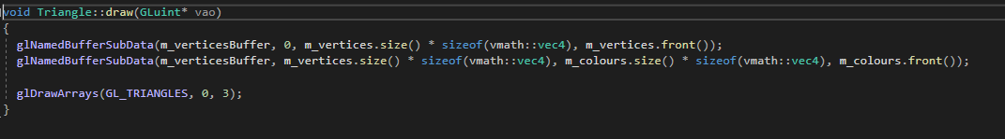
Just before I draw the triangle, I fill buffer with the most recent vertex and colour data.

